A MINI PROJECT REPORT
ON
“SecureDrop v2 — Advanced Secure File Sharing on AWS”
SUBMITTED BY
Prathmesh Mulay 123B1B198
Parth Patil 123B1B213
Vedant More 123B1B195
Under the guidance
of
Mrs. Dipali Patil
Third Year Sem-II

DEPARTMENT OF COMPUTER ENGINEERING PIMPRI CHINCHWAD COLLEGE OF ENGINEERING
2025-2026

Table of Contents

1. Introduction.

2. Objectives.

3. Technologies and AWS Services Used.

4. System Architecture.

4.1 Architecture Flow.

4.2 Architecture Overview Diagram..

5. Implementation Details.

5.1 EC2 Setup and Environment

5.2 Flask Application — Upload Workflow.

5.3 Flask Application — Download Workflow.

5.4 DynamoDB Schema.

5.5 Lambda Cleanup Function.

5.6 Frontend Design.

6. Security Features and Cybersecurity Concepts.

7. Comparison: FA1 vs FA2.

8. Advantages of SecureDrop v2.

9. Threat Model

10. Security Principles Mapping.

11. Limitations and Future Scope.

11.1 Current Limitations.

11.2 Future Enhancements.

12. Conclusion.

13. Appendix — Project Screenshots.

1. Introduction
The FA1 project established a foundational cloud-based file sharing system using Amazon EC2 and Amazon S3, where users could upload files through a browser interface and retrieve them via time-limited presigned URLs. While functional and demonstrating core AWS integration, that system had several acknowledged limitations — including no user authentication, no automatic file deletion, single-file uploads only, and no cybersecurity perimeter controls.
This FA2 report documents the redesign and significant enhancement of that system into SecureDrop v2 — a production-grade, cybersecurity-focused secure file sharing application. The upgraded system introduces password-protected download links, multi-file upload support, configurable download limits, automated file deletion via AWS Lambda, and a comprehensive security layer including AWS WAF, bcrypt hashing, and CloudTrail audit logging.
SecureDrop v2 directly addresses every limitation identified in the FA1 conclusion and transforms the project from a basic cloud storage demonstration into a real-world cloud-native cybersecurity application, suitable as a reference implementation for secure temporary data exchange on AWS.

2. Objectives
Building upon the FA1 foundation, the FA2 objectives are:
- Add password-protected, bcrypt-hashed download links to enforce access control
- Support multi-file upload under a single shareable link
- Implement configurable download limits (e.g., max 5 downloads per link)
- Automate file expiry and deletion from S3 using AWS Lambda and EventBridge
- Integrate AWS WAF to block SQL injection (SQLi) and Cross-Site Scripting (XSS) attacks
- Store link metadata in Amazon DynamoDB for persistent tracking across requests
- Enforce IAM least-privilege access across all AWS services
- Enable CloudTrail audit logging to record all S3 access and deletion events
- Deploy the Flask application with Gunicorn for production-grade stability

3. Technologies and AWS Services Used

Technology / Service | Role in SecureDrop v2
AWS EC2 (Ubuntu) | Hosts the Flask/Gunicorn web application — the application tier
AWS S3 | Stores all uploaded files with AES-256 server-side encryption (SSE-S3)
AWS DynamoDB | Stores link metadata: password hash, expiry time, download count, file keys
AWS Lambda | Scheduled cleanup function — scans DynamoDB and deletes expired files from S3
Amazon EventBridge | Triggers the Lambda cleanup function on a schedule (every 30 minutes)
AWS WAF | Web Application Firewall — uses managed rule groups to detect and block common web exploits (SQLi, XSS) and malicious request patterns before reaching the application layer
AWS IAM | Role-based access control — no hardcoded credentials anywhere in the codebase
AWS CloudTrail | Audit trail — logs all S3 data events (uploads, downloads, deletions)
Python 3 / Flask | Primary backend language and web framework
Boto3 | Official AWS SDK for Python — interfaces with S3, DynamoDB, and IAM
bcrypt | Industry-standard password hashing — protects download passwords at rest
Gunicorn | Production WSGI server — replaces Flask dev server for stability
python-dotenv | Loads environment variables from .env securely at runtime
Application Load Balancer (ALB) | Routes HTTPS traffic from WAF to EC2 (Gunicorn) and integrates with AWS WAF for perimeter defence; the EC2 instance is only reachable through the ALB

4. System Architecture
SecureDrop v2 adopts a multi-service cloud-native architecture. Unlike FA1 which used only EC2 and S3, the FA2 architecture integrates five AWS services working in concert, with clear separation of responsibilities:

# | Component | Responsibility
1 | User Browser | Accesses the upload and download web interface
2 | AWS WAF | Filters incoming HTTP traffic — blocks SQLi, XSS, and malicious bots before requests reach EC2
3 | EC2 + Flask/Gunicorn | Processes upload requests, hashes passwords, writes metadata to DynamoDB, uploads encrypted files to S3, generates presigned URLs
4 | Amazon S3 | Stores uploaded files with AES-256 server-side encryption; files are private by default — access only through presigned URLs
5 | Amazon DynamoDB | Persists link records: link ID, bcrypt password hash, file keys, expiry timestamp, max downloads, download count, active status
6 | AWS Lambda | Periodic cleanup — triggered by EventBridge every 30 minutes; scans DynamoDB for expired/overcount links, deletes associated S3 objects, marks links inactive
7 | Amazon EventBridge | Scheduled rule that invokes the Lambda cleanup function on a recurring timer
8 | AWS CloudTrail | Records all S3 API calls (PutObject, GetObject, DeleteObject) for compliance and audit
9 | IAM Role | Grants EC2 and Lambda least-privilege access to S3 and DynamoDB — no access keys in code

4.1 Architecture Flow
The end-to-end data flow in SecureDrop v2 follows these steps:
- Step 1 — UPLOAD: User selects files, sets a password, expiry duration, and download limit on the web interface.
- Step 2 — WAF FILTER: All inbound HTTP requests pass through AWS WAF, which rejects requests matching SQLi or XSS patterns before they reach the Application Load Balancer (ALB).
- Step 3 — FLASK PROCESSING: The Flask app on EC2 validates inputs, hashes the password with bcrypt, uploads each file to S3 with SSE-S3 encryption enabled, and writes a link record to DynamoDB.
- Step 4 — LINK GENERATION: A unique link ID is returned to the uploader. Recipients navigate to /d/<link_id> to reach the download page.
- Step 5 — DOWNLOAD: The recipient enters the password. Flask verifies the bcrypt hash, checks the expiry timestamp and download count from DynamoDB, increments the count, then generates 15-minute presigned URLs for each file.
- Step 6 — AUTO-EXPIRY: EventBridge triggers Lambda every 30 minutes. Lambda scans DynamoDB for expired or exhausted links, deletes the corresponding S3 objects, and marks the links inactive.

4.2 Architecture Overview Diagram
User Browser
|
[AWS WAF] ← blocks SQLi / XSS / bad bots
|
[ALB] (Application Load Balancer)
|
[EC2 — Flask/Gunicorn] → [Amazon S3] (AES-256 encrypted files)
|↘ [DynamoDB] (link metadata: hash, expiry, count)
[Lambda + EventBridge] (cleanup every 30 min)

5. Implementation Details

5.1 EC2 Setup and Environment
The application is deployed on an Ubuntu EC2 instance. The following steps were performed to set up the environment:
- System packages updated and Python 3, pip, venv, and Gunicorn installed
- A Python virtual environment created at ~/securedrop/venv to isolate dependencies
- Dependencies installed: flask, boto3, bcrypt, python-dotenv, gunicorn
- Environment variables (S3 bucket name, AWS region, Flask secret key) stored in a .env file — never hardcoded
- IAM Role (securedrop-ec2-role) attached to the EC2 instance with permissions for S3, DynamoDB, and CloudWatch Logs
- EC2 Security Group configured to allow inbound TCP on port 5000 only from the ALB security group; the instance is not publicly accessible. The EC2 instance is not internet-facing and is only reachable through the ALB, enforcing network-level isolation.
- Application run persistently via GNU Screen + Gunicorn (3 workers, 120s timeout)

5.2 Flask Application — Upload Workflow
The upload endpoint (/upload) implements the following logic:
- Accepts multiple files via multipart/form-data POST request
- Validates: at least one file selected, password provided, expiry between 1–72 hours, download limit between 1–50
- File extension whitelist enforced: pdf, png, jpg, jpeg, gif, txt, zip, docx, xlsx, mp4
- Individual file size capped at 100 MB; oversized files are rejected with an error message
- Each file uploaded to S3 under a unique path: <link_id>/<uuid>_<filename> with SSE-S3 encryption and ContentDisposition header set
- Password hashed with bcrypt (salted, 12 rounds) before storage — plaintext never persisted
- A DynamoDB record written containing: link_id, password_hash, list of file keys, expiry_time (ISO 8601 UTC), max_downloads, download_count (starts at 0), active (True)
- The shareable URL /d/<link_id> returned to the uploader as JSON

5.3 Flask Application — Download Workflow
The download flow operates across two routes:
- /d/<link_id> — Renders the download page. Fetches the DynamoDB record, checks if active and not expired. Displays filenames, remaining download count, and a live countdown timer.
- /d/<link_id>/verify (POST) — Accepts the entered password. Verifies bcrypt hash. Checks expiry and download count. On success, increments download_count in DynamoDB, deactivates the link if the limit is reached, and returns 15-minute presigned URLs for each file.
- If the link is expired, exhausted, or inactive, the expired.html template is returned with HTTP 410 Gone.
- The /status/<link_id> endpoint provides a JSON response with real-time link status, used by the countdown timer on the frontend.

5.4 DynamoDB Schema
A single DynamoDB table (securedrop-links) is used with a simple key schema:

Attribute | Description / Type
link_id (PK) | UUID string — partition key; maps directly to the URL token
password_hash | bcrypt-hashed password string (String)
files | List of maps: [{s3_key, original_name}] — one entry per uploaded file
expiry_time | ISO 8601 UTC timestamp string — when the link becomes invalid
max_downloads | Number — maximum allowed download events
download_count | Number — current download count; atomically incremented on each valid access
active | Boolean — False when expired or download limit reached; used to short-circuit DB queries

DynamoDB was chosen over a relational database because the access pattern is purely key-based (get/put/update by link_id), making it a perfect fit for DynamoDB's single-table design. The PAY_PER_REQUEST billing mode ensures zero cost at low usage.

5.5 Lambda Cleanup Function
A Python Lambda function (securedrop-cleanup) handles automated file deletion:
- Triggered by an Amazon EventBridge scheduled rule every 30 minutes
- Scans the DynamoDB table with a filter: active = True AND expiry_time < current UTC time
- For each matching record, iterates over the files list and calls s3.delete_object() for each S3 key
- Updates the DynamoDB record to set active = False after deletion
- Returns a count of deleted files for CloudWatch log monitoring. Cleanup is eventual (≤30 min delay), ensuring consistency without continuous compute cost.
This Lambda directly addresses the primary limitation identified in FA1: files were previously never deleted from S3 after link expiry. Download-limit exhaustion is also handled: the Flask app deactivates links server-side immediately when the count is reached, and Lambda handles time-based expiry. Lambda execution logs are monitored via CloudWatch for operational visibility.

5.6 Frontend Design
The web interface spans four HTML templates:
- index.html — Upload interface with drag-and-drop file zone, password field, expiry selector (1h to 72h), max downloads input, and a results panel that displays the generated link with a copy button.
- download.html — Download page showing filenames, remaining download count, a live countdown timer (JavaScript, updates every second), and a password entry form.
- links.html — Shown after successful password verification; displays presigned download URLs (valid 15 minutes) for all files in the bundle.
- expired.html — Shown for inactive or expired links; displays a clear expiry message and a link back to the upload page.
All templates use a consistent dark theme (background #0f1117) with system-ui fonts and responsive card layouts. No external CSS frameworks are used.

6. Security Features and Cybersecurity Concepts
SecureDrop v2 implements a layered defence-in-depth security model, covering the network perimeter, application layer, data storage, and access control:

Security Mechanism | Implementation Detail
AWS WAF | Managed rule sets applied: AWSManagedRulesCommonRuleSet (blocks SQLi, XSS, bad bots) and AWSManagedRulesSQLiRuleSet (additional SQL injection protection). Attached to the Application Load Balancer in front of EC2.
bcrypt Password Hashing | Download passwords are hashed with bcrypt (salted, adaptive cost factor) before storage in DynamoDB. Plaintext passwords are never persisted. Verification uses constant-time comparison to prevent timing attacks.
S3 Server-Side Encryption (SSE-S3) | Every uploaded file is encrypted at rest using AES-256 via S3's SSE-S3 mechanism, specified as ExtraArgs={'ServerSideEncryption': 'AES256'} in the boto3 upload call.
Presigned URLs (15-minute expiry) | After password verification, files are served via presigned URLs signed with AWS Signature Version 4, valid for 900 seconds (15 minutes). Presigned URLs grant temporary, scoped access to private S3 objects without exposing bucket permissions. Files are never made publicly accessible.
Time-Limited Link Expiry | Each link carries an expiry_time stored in DynamoDB. All access routes check this timestamp against current UTC before serving content. Expired links return HTTP 410 Gone.
Download Limit Enforcement | download_count is tracked in DynamoDB. Flask increments it on each successful download and deactivates the link when max_downloads is reached. Atomic updates ensure accurate download_count increments under concurrent access. Lambda enforces time-based expiry independently.
IAM Least-Privilege Roles | EC2 uses securedrop-ec2-role; Lambda uses a separate execution role. Each role has only the minimum permissions required (S3 read/write/delete, DynamoDB read/write). No access keys are hardcoded.
File Type Whitelist | Only approved extensions (pdf, png, jpg, jpeg, gif, txt, zip, docx, xlsx, mp4) are accepted. Any other type is rejected at the server with HTTP 400.
File Size Limit (100 MB) | Uploads exceeding 100 MB are rejected server-side before any S3 operation is attempted, protecting against resource exhaustion.
CloudTrail Audit Logging | S3 data events (PutObject, GetObject, DeleteObject) are logged via AWS CloudTrail to a separate log bucket, providing a tamper-evident audit trail of all file operations.
No Hardcoded Credentials | All AWS credentials are sourced from the EC2 IAM role and Lambda execution role via the AWS metadata service. The .env file stores only non-sensitive config (bucket name, region).
Input Validation | Expiry hours (1–72), download limits (1–50), and file extension are all validated server-side regardless of client-side checks, preventing bypass via direct API calls.

7. Comparison: FA1 vs FA2

Feature | FA1 (Base Project)
Feature | FA1 (Base) | FA2 (SecureDrop v2)
File Storage | S3 (no encryption specified) | S3 with AES-256 SSE-S3 encryption
Download Link | Presigned URL (10 min, public) | Password-protected, bcrypt-hashed, presigned (15 min)
Multi-file Upload | Not supported | Supported — multiple files per link bundle
Download Limit | None | Configurable (1–50 downloads per link)
Automatic File Deletion | Not implemented (FA1 limitation) | AWS Lambda + EventBridge (every 30 min)
Link Metadata Storage | None (stateless) | Amazon DynamoDB (persistent tracking)
Web Application Firewall | Not implemented | AWS WAF (SQLi + XSS managed rules)
Audit Logging | Not implemented | AWS CloudTrail (S3 data events)
Password Security | Not applicable | bcrypt with salt (constant-time verification)
Expiry Configuration | Fixed 10 min (hardcoded) | User-selectable: 1h to 72h
Application Server | Flask dev server | Gunicorn (3 workers, production-ready)
Number of AWS Services | 2 (EC2, S3) | 7 (EC2, S3, DynamoDB, Lambda, EventBridge, WAF, CloudTrail)

8. Advantages of SecureDrop v2
- Comprehensive security perimeter — WAF, bcrypt, encryption at rest, presigned URLs, and IAM work together as a layered defence
- Zero long-term file exposure — files are guaranteed to be deleted by Lambda even if the uploader forgets
- No credential risk — IAM roles eliminate the possibility of access key leakage in code or logs
- Audit compliance — CloudTrail logs provide a complete record of all file operations for security review
- Scalable architecture — stateless Flask app + DynamoDB + S3 enables horizontal scaling behind ALB with no capacity planning required
- Production-grade deployment — Gunicorn with multiple workers handles concurrent requests reliably
- Extensible design — the DynamoDB-backed link model makes it straightforward to add features like one-time links, email notifications, or virus scanning

9. Threat Model
SecureDrop v2 was designed with the following threat scenarios explicitly considered and mitigated:
Threat | Mitigation
Unauthorized access to files | Password protection + bcrypt hashing (salted, constant-time verification)
Link sharing abuse (overuse / forwarding) | Configurable expiry time + download limits enforced server-side in DynamoDB
Injection attacks (SQLi / XSS) | AWS WAF managed rule groups (AWSManagedRulesCommonRuleSet + AWSManagedRulesSQLiRuleSet) block malicious patterns at the perimeter
Data exposure (S3 bucket breach) | Private S3 bucket (no public access) + SSE-S3 AES-256 encryption at rest + presigned URL delivery only
Credential leakage (hardcoded keys) | IAM instance roles — no access keys exist in code, config files, or environment variables
Malicious / oversized file upload | File extension whitelist (10 types) + 100 MB per-file size cap enforced server-side before any S3 operation

10. Security Principles Mapping
The security controls implemented in SecureDrop v2 map directly to foundational cybersecurity principles:
Security Principle | Implementation in SecureDrop v2
Least Privilege | IAM roles grant only the minimum permissions required — separate roles for EC2 and Lambda; no admin access anywhere
Confidentiality | SSE-S3 AES-256 encryption at rest + presigned URL delivery ensures data is never exposed directly
Integrity | Server-side input validation + bcrypt verification + controlled access flow prevent tampered or bypassed requests
Availability | ALB + Gunicorn multi-worker deployment + AWS managed services (DynamoDB, S3, Lambda) provide resilience and handle concurrent load
Defence-in-Depth | WAF (perimeter) + application logic (validation, bcrypt) + IAM (access control) + encryption (at rest) + CloudTrail (audit) — multiple independent layers ensure no single point of failure

11. Limitations and Future Scope

11.1 Current Limitations
- WAF requires an Application Load Balancer (ALB) — cannot be attached directly to an EC2 public IP, adding minor setup complexity
- No virus scanning — uploaded files are stored without malware analysis (ClamAV via Lambda layer is a planned enhancement)
- No HTTPS — the application currently runs on HTTP port 5000; a production deployment would require an ACM certificate and domain
- Lambda scan is not real-time — there is up to a 30-minute window between link expiry and actual file deletion from S3
- No user authentication for the upload page — anyone with the EC2 URL can upload files

11.2 Future Enhancements
- ClamAV virus scanning Lambda layer — scan every uploaded file before storing; reject infected files automatically
- HTTPS via AWS Certificate Manager — terminate TLS at the ALB for end-to-end encrypted communication
- Amazon SNS notifications — email the uploader when a link is accessed or expires
- Amazon Cognito authentication — require login to upload; restrict the system to authorized users only
- Amazon Macie — automatically detect and alert on sensitive data (PII, credentials) uploaded to the S3 bucket
- S3 Lifecycle Policy — complement Lambda with a native S3 lifecycle rule as a redundant deletion mechanism
- One-time download links — destroy the link and files immediately after the first successful download

12. Conclusion
SecureDrop v2 represents a substantial evolution from the FA1 baseline. The project transformed a simple EC2+S3 file sharing proof-of-concept into a multi-service, cybersecurity-focused cloud application that addresses all limitations identified in the first iteration.
The integration of AWS DynamoDB for persistent state management, Lambda for automated lifecycle enforcement, WAF for perimeter security, and CloudTrail for audit compliance demonstrates how modern cloud applications leverage multiple AWS managed services — each handling a distinct responsibility — rather than placing all logic on a single server.
From a cybersecurity perspective, the project implements defence-in-depth: password hashing (bcrypt), encryption at rest (AES-256/SSE-S3), network-level attack filtering (WAF), time-limited access (presigned URLs + expiry logic), and audit logging (CloudTrail). Together, these controls map directly to real-world cloud security principles including least privilege, data minimization, and continuous monitoring.
This project serves as a practical, reproducible reference implementation for secure temporary file exchange on AWS, and provides a solid foundation for further enhancements in subsequent project iterations.

Project Summary — SecureDrop v2
Platform: AWS (EC2 · S3 · DynamoDB · Lambda · EventBridge · WAF · CloudTrail · IAM)
Backend: Python 3 · Flask · Boto3 · bcrypt · Gunicorn
Security: WAF · bcrypt · SSE-S3 · Presigned URLs · IAM · CloudTrail · Input Validation
Link Validity: User-configurable (1h – 72h) · Max Downloads: User-configurable (1–50)

13. Appendix — Project Screenshots
The following screenshots document the AWS infrastructure, working application, and security configurations for SecureDrop v2.

Screenshot 1
Figure 1: EC2 Instance Details — Ubuntu instance running in eu-north-1 (Stockholm) with securedrop-ec2-role attached
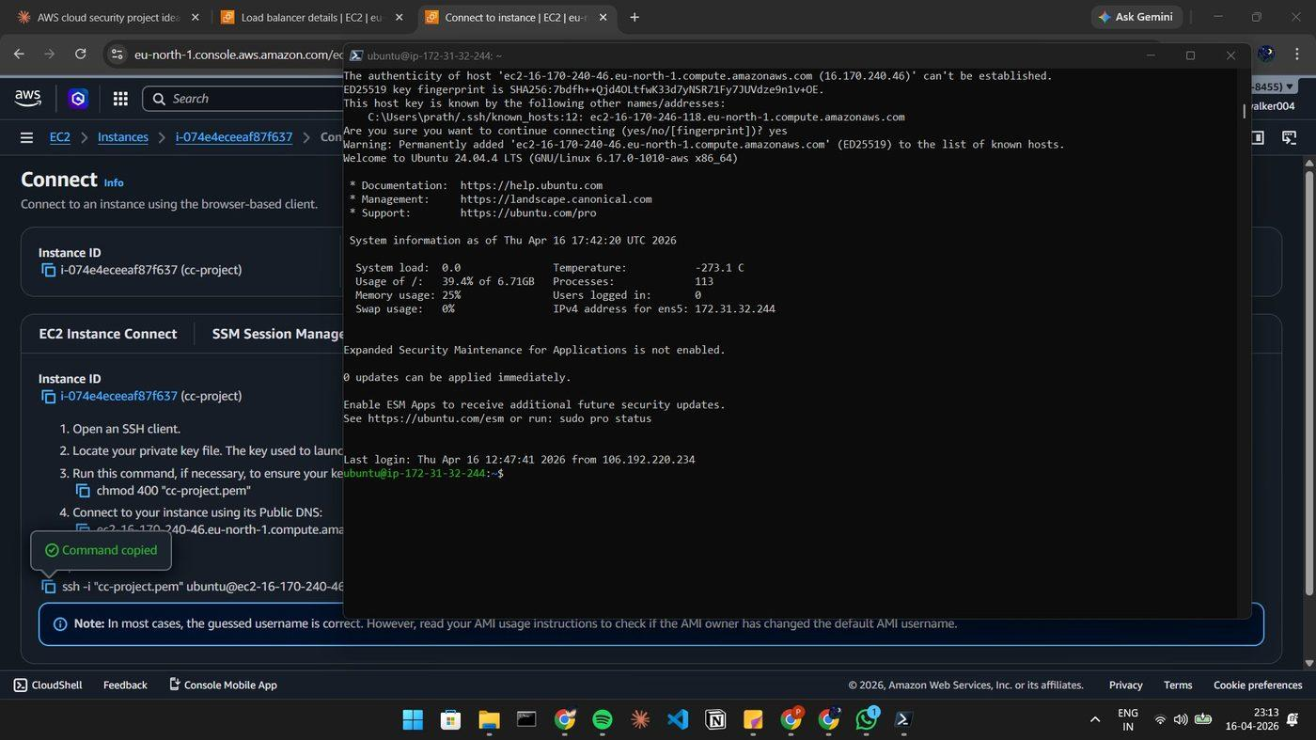
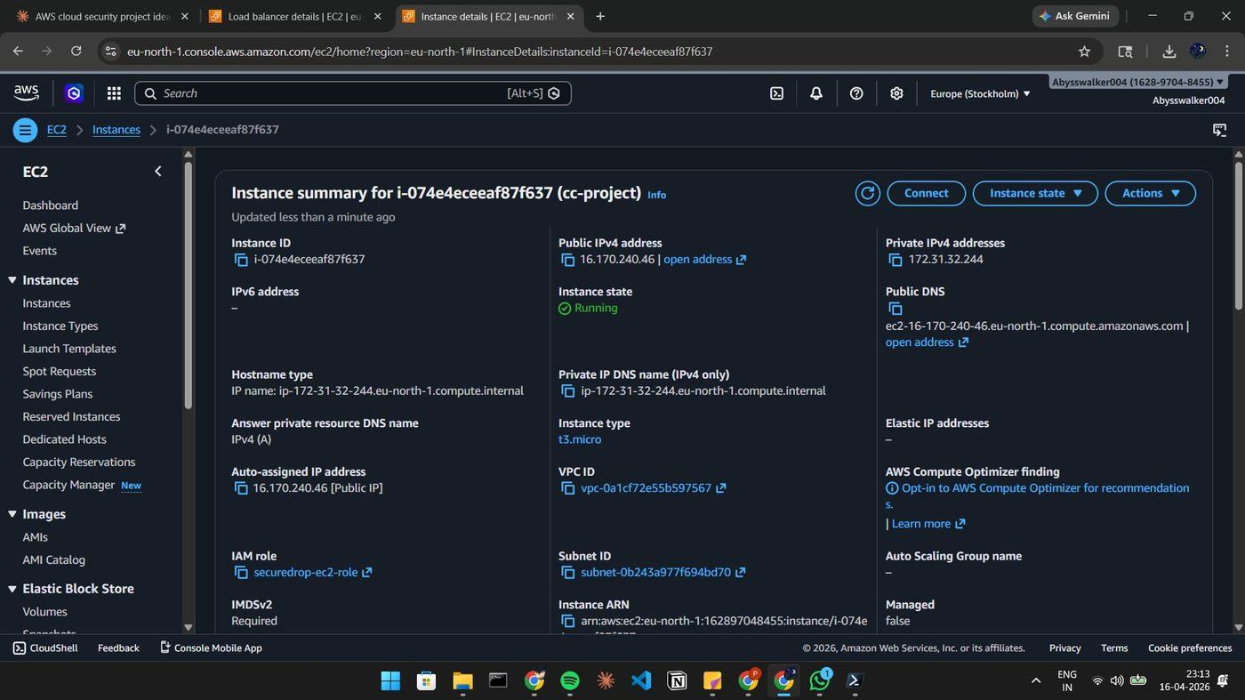
Figure 1c: Application Load Balancer (cc-project-alb) — Active, Internet-facing, eu-north-1
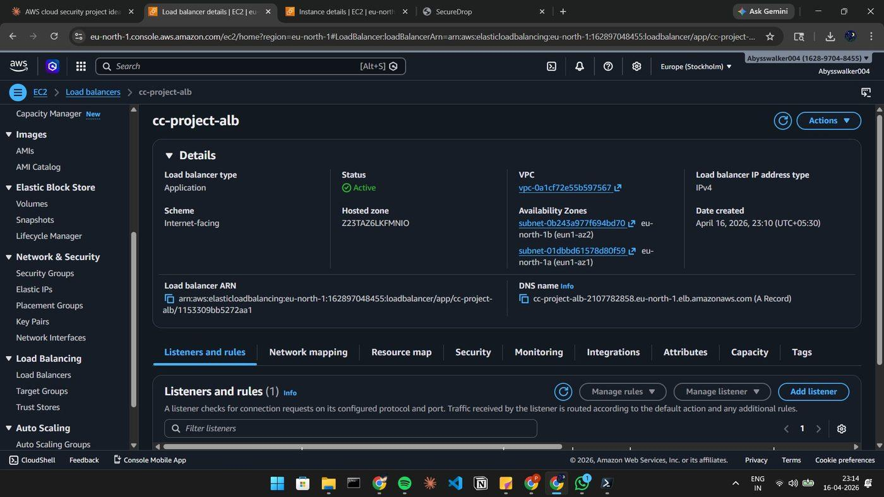

Screenshot 2
Figure 2: Amazon S3 Bucket — Encrypted file storage bucket with SSE-S3 enabled
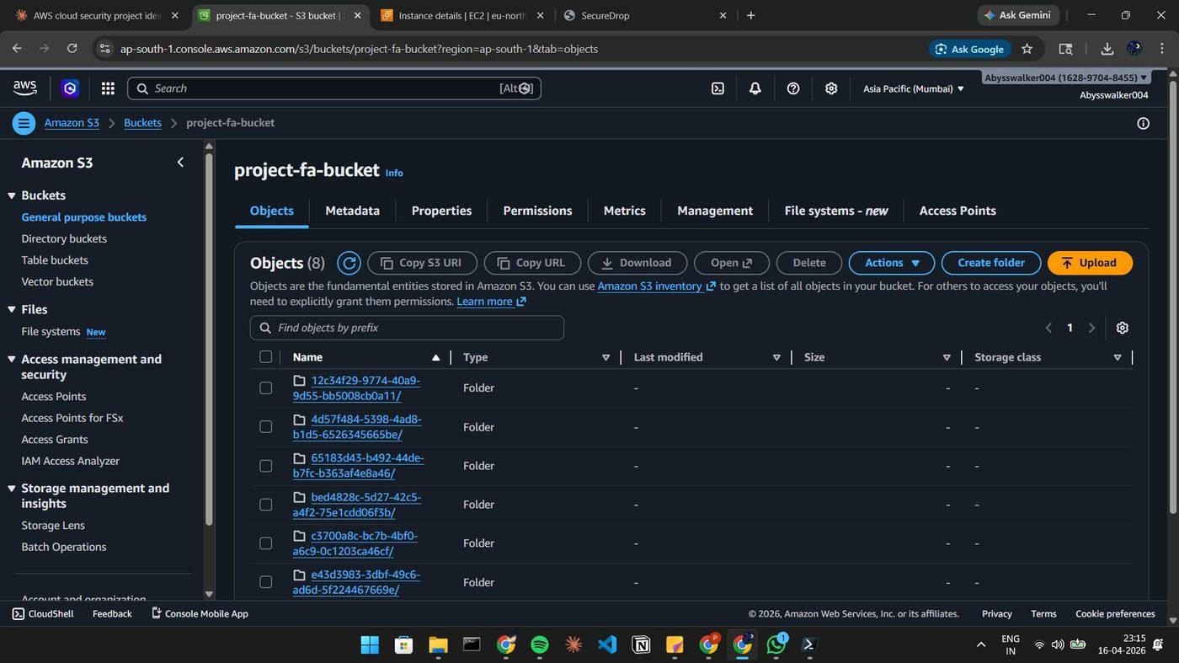

Screenshot 3
Figure 3: Amazon DynamoDB — securedrop-links table with sample link record showing all attributes
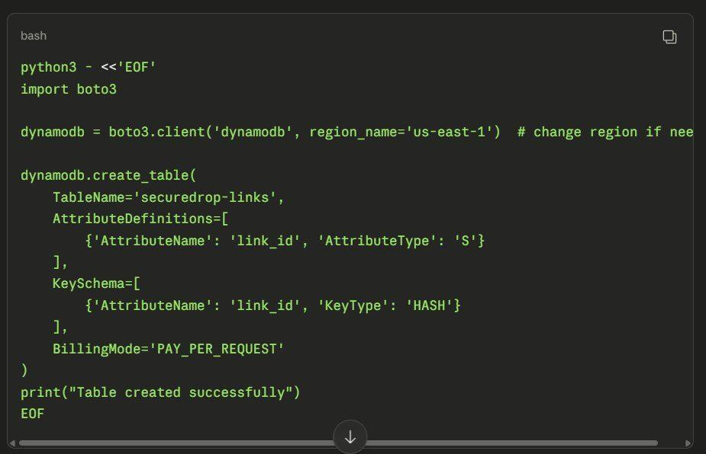

Screenshot 4
Figure 4: AWS Lambda — securedrop-cleanup function with EventBridge trigger (rate: 30 minutes)

Screenshot 5
Figure 5: AWS WAF — Web ACL with AWSManagedRulesCommonRuleSet and AWSManagedRulesSQLiRuleSet
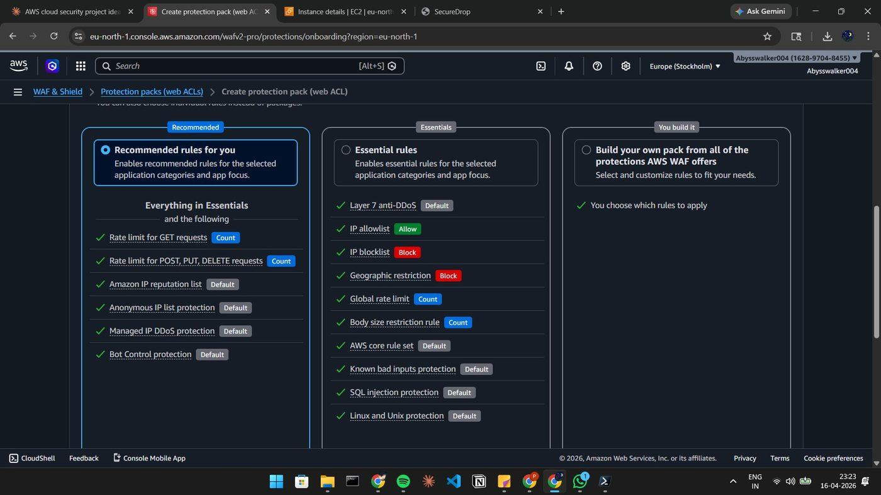
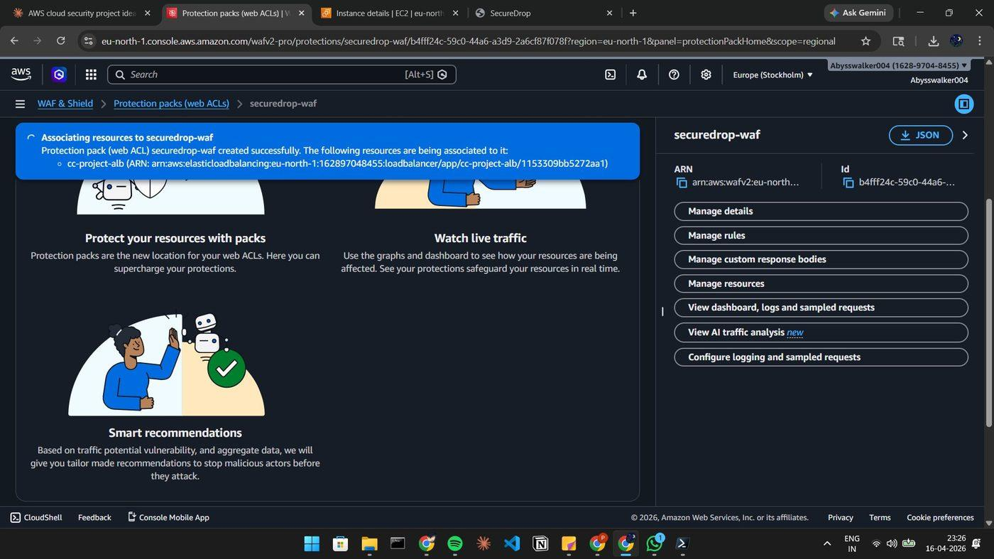
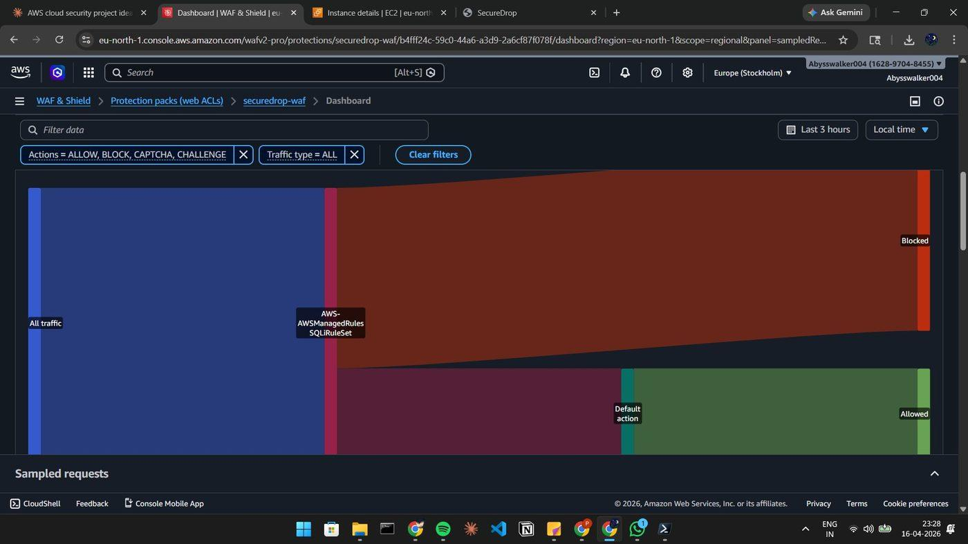
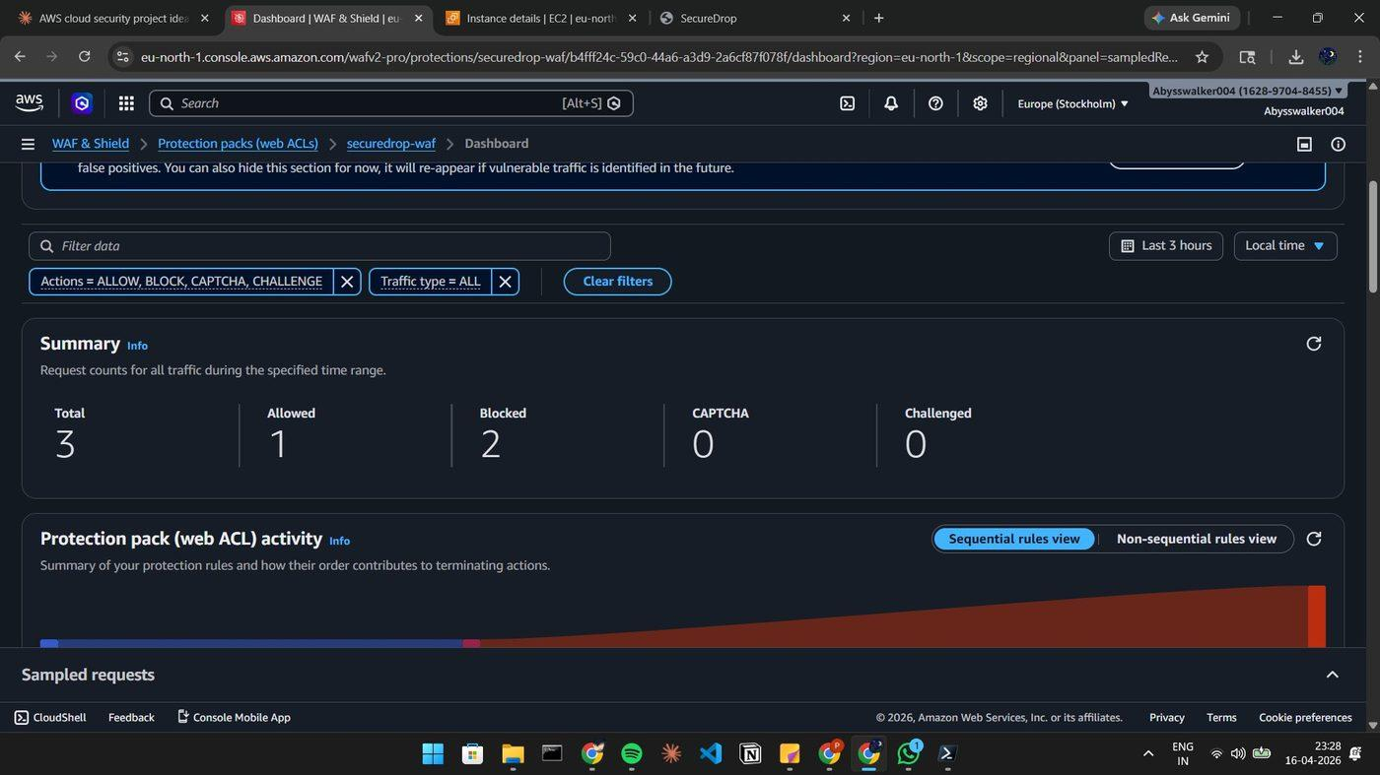

Screenshot 6
Figure 6: IAM Roles — securedrop-ec2-role and Lambda execution role with minimum required permissions
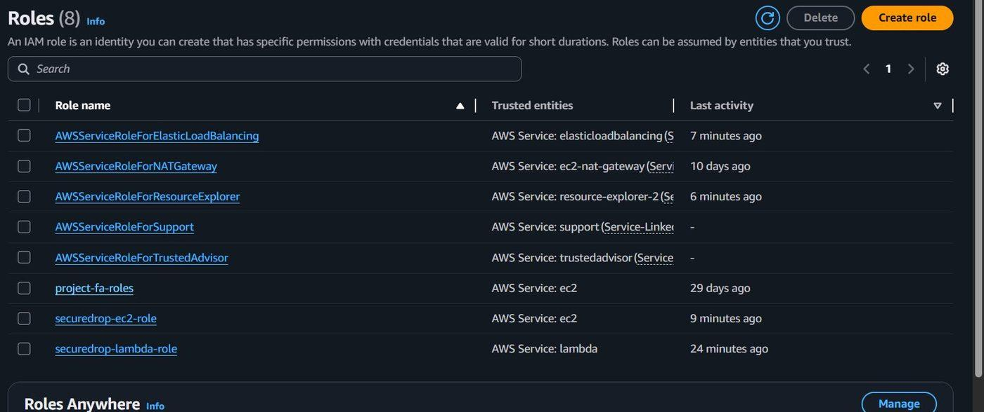

Screenshot 7
Figure 7: EC2 Terminal — app.py running via Gunicorn (3 workers) on port 5000

Screenshot 8
Figure 8: Upload Interface — drag-and-drop file zone, password field, expiry selector, and download limit input
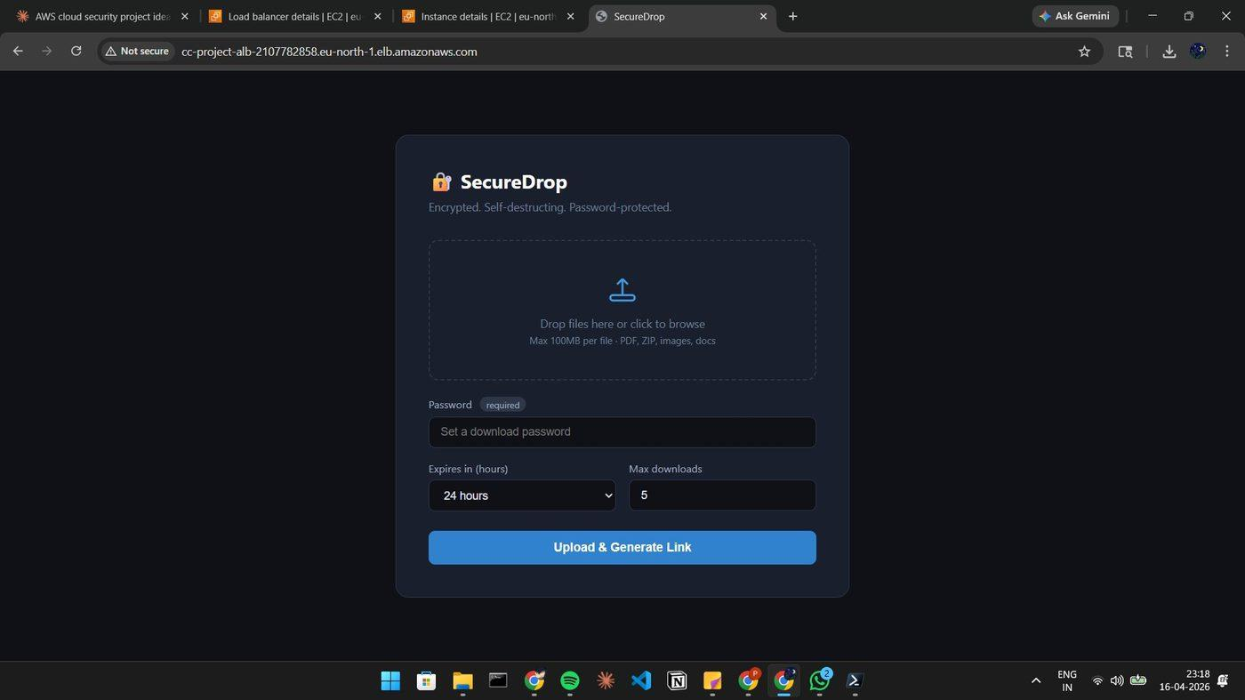
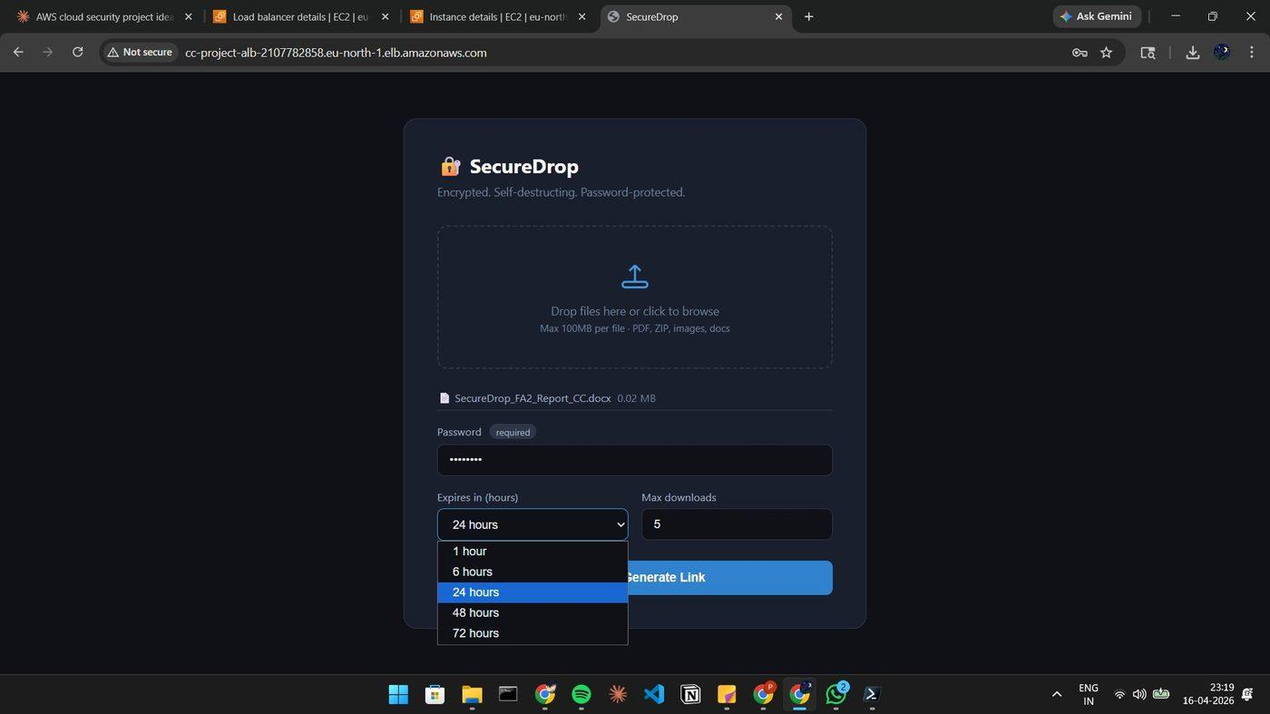

Screenshot 9
Figure 9: Generated Share Link — link ID returned after successful multi-file upload
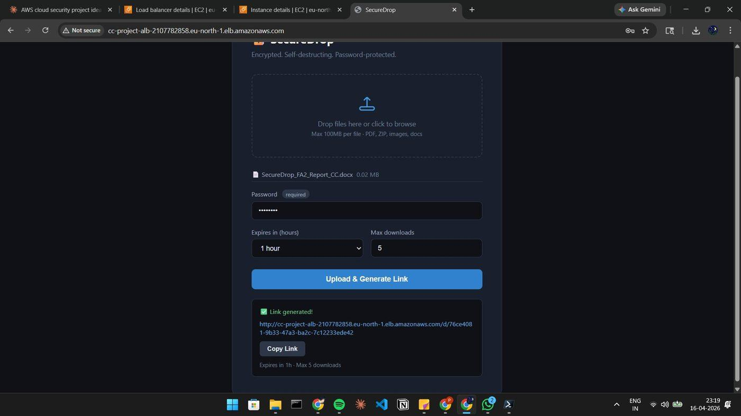

Screenshot 10
Figure 10: Download Page — password entry form with live countdown timer and remaining download count badge
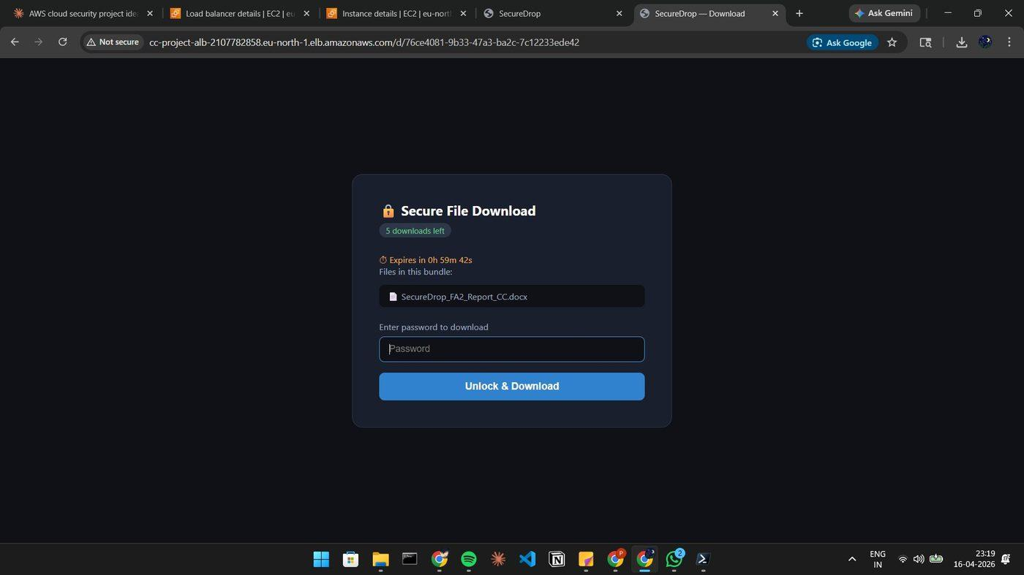
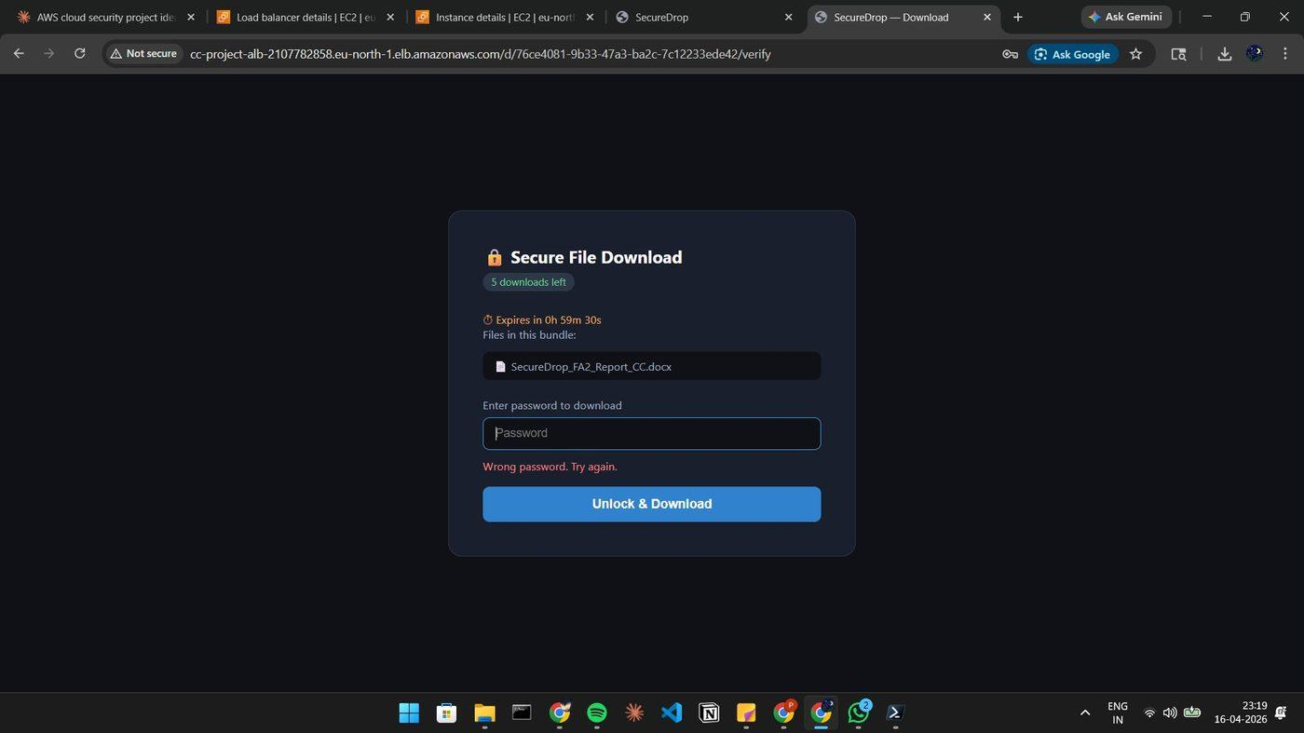

Screenshot 11
Figure 11: Presigned Download Links — 15-minute access URLs displayed after successful password verification
